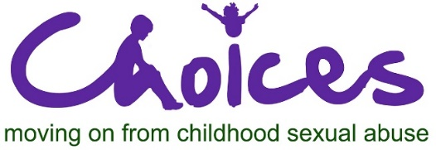

Alex Wood Hall Norfolk Street Cambridge CB1 2LD 01223 358149
admin@choicescounselling.co.uk www.choicescounselling.co.uk

CHOICES is looking for a part-time
CLIENT SERVICE MANAGER

12-14 hours per week,

CHOICES is a registered charity (No. 291945) working with adult survivors of childhood sexual abuse. We provide individual weekly counselling for up to two years. The service is delivered by a highly committed team of volunteer and paid counsellors. We run a training course on “Understanding the effects of childhood sexual abuse” which is the way we recruit volunteer counsellors to the service.

We are looking for a qualified counsellor to join our small management team. The key requirement is to provide weekly clinical and administrative support to a team of counsellors spread throughout Cambridgeshire. Currently, most counsellors are providing a remote service from their home or our head office in Cambridge.

The Client Service Manager is required to undertake clients’ assessments and the allocation process of clients to counsellors alongside its associated administration. They will provide clinical supervision to counsellors when needed.

They will be involved in training, recruitment, and development of new counsellors, including leading a monthly CPD group for counsellors. They will also be instrumental in the development of the service in Cambridgeshire.

The Client Service Manager will report to the Managing Director and will work with her, a peer Client Service Manager and with the Finance and Administration assistants, who are all based in Cambridge.

This post requires a qualified counsellor, with post qualification experience, as well as experience of working with survivors of sexual abuse, and who is a member of a recognised governing body, such as BACP.

The position is for 12-14 hrs per week to be worked flexibly during the hours the service operates, for a fixed term two-year contract. Some working from home (or suitable location) will be required.

For inquiries and a job description please contact Victoria Stevenson, Head of Services at services@choicescounselling.co.uk or call 07763 677796.

Closing date for applications is 17th December 2020. Interviews early January 2021.

